AbilityNet Factsheet – April 2019

Repetitive strain injury (RSI) in the workplace
This factsheet looks at repetitive strain injury (RSI) – the term most often used to describe the pain felt in muscles, nerves and tendons caused by repeated movement and overuse. It looks at the symptoms and causes of RSI (also known as Upper limb disorders (ULDs), cumulative trauma disorder or occupational overuse syndrome.
Work Related Upper Limb Disorders) and the steps that individuals or employers can take to protect themselves and their staff.
It is important that employers understand their legal responsibility to provide any ‘reasonable adjustments’ to protect their staff from injury and prevent discrimination. Computer use is one significant cause of RSI, and this factsheet includes practical information on both reducing the risk and responding effectively to any cases that may arise in an office environment.

Table of Contents
1. What is RSI? 3
2. What are the symptoms of RSI? 3
3. Why worry about RSI? 3
4. Can RSI be treated? 4
5. What should employers do to prevent RSI? 4
6. How can RSI be prevented? 5
7. How should workstations be set up? 5
8. What other aids can help prevent RSI? 7
9. What about laptops, tablets and smartphones? 7
10. Useful links and resources 8
Health and Safety Executive (HSE) 8
NHS Choices 8
11. How can AbilityNet help you? 9
My Computer My Way 9
Workplace Assessment Service 9
Consultancy services 9
DSA / Student assessments 10
About AbilityNet 10
Support us 10
Contact us 10
12. Copyright information 10

What is RSI?
Repetitive strain injury (RSI) refers to work-related injuries to the muscles, tendons, nerves and soft tissue in the upper limbs. It usually affects the neck, shoulders, forearms, elbows, wrists and / or hands. RSI is a painful and potentially debilitating condition that, if left untreated, can lead to permanent damage.
The most significant risk factors for RSI include:
- carrying out repetitive tasks for long periods without suitable rest breaks
- poor posture or activities that require you to work in an awkward position
- poor working environment setup
RSI is most commonly caused by repeated actions that are carried out on a daily basis over a long period.

What are the symptoms of RSI?
RSI symptoms can vary but often include:
- Pain or tenderness
- Stiffness or joint restriction
- Tingling or numbness
- Cramping
- Swelling in the hands or forearms
- Referred pain – where the pain is felt in a different part of the body to the one that is injured.
There are two main types of RSI:
- Type 1 - pain is the result of a recognised medical condition such as tendonitis, cellulitis or carpal tunnel syndrome.
- Type 2 - no specific diagnosis can be made, and the injury is often referred to as non-specific upper limb pain or diffuse RSI.

Why worry about RSI?
Statistics from the Labour Force Survey suggest that in the UK alone, there are over 200,000 cases of work-related upper limb disorders (ULD) every year.
In addition to the pain and discomfort experienced by individual workers, RSI also carries significant costs for employers.
The Health and Safety Executive (HSE) estimates that 2.6 million working days were lost in 2017/18 due to ULDs – with an average of 14 days lost for each case.

Can RSI be treated?
If you develop any symptoms of RSI, you should speak as soon as possible to your employer or occupational health specialist about any ways that you could modify your working environment and tasks to relieve your discomfort or pain.
If your symptoms persist, then you should contact your GP.
It is important to address any possible symptoms of RSI as early as possible because, without appropriate adjustments and any necessary treatment, it may progress from mild to severe.
- Early stage RSI (mild) – Aches and pain or tiredness occur during work but improve with rest. Performance may not be affected. This stage may last weeks or months but is reversible.
- Intermediate stage RSI (moderate) – Pain and tiredness occur early in the work shift, persist away from work and may disturb sleep. Capacity for repetitive work may be reduced. Physical signs (e.g. swelling of the tendon areas) may be visible. This stage may last several months.
- Late stage RSI (severe) – Pain, tiredness and weakness persist even with complete rest. Sleep is often adversely affected, and you may be unable to perform even light tasks at home or work. This stage is sometimes irreversible, and you may never get back full use of the affected part of your body.
Not everyone goes through these stages in the same way, but the first pain, numbness or tingling experienced is a clear signal that you need to act and that your affected muscles and tendons need to rest and recover.
Early intervention is key. Any member of the Chartered Association of Physiotherapists (MCAP) can provide a number of simple exercises to help alleviate early symptoms of RSI, hopefully leading to full recovery.

What should employers do to prevent RSI?
Employers have a legal duty to provide safe working conditions, employers also have a common law ‘duty of care’ towards their staff.
Under the Health and Safety Act, employers must carry out a risk assessment of any task or equipment that may cause injury. This includes the setup of computer equipment and workstations. For staff who regularly use computers or laptops, employers must follow the guidance given in the Display Screen Equipment (DSE) Regulations.
To reduce the risk of RSI or any other harm or injury, employers should also:
- consult employees on potential risks arising from their work
- consider changing the way work is organised
- provide clear instructions, information and training on any measures being taken to control the risks
- help sufferers when they come back to work.
Employers who do not meet their statutory responsibilities for health and safety, or who fail in their duty of care, may face employment tribunal. One study by the HSE found that most of the compensation claims made against call centre operators came from RSI sufferers.
Employers could also be vulnerable to claims of discrimination under the Equality Act if they fail to make ‘reasonable adjustments’ for a disabled employee.

How can RSI be prevented?
Prevention of RSI is far easier than cure. Even if you do not have any symptoms, you should adapt your work to reduce risk:
- adjusting your workstation to ensure it is set up properly for you to work comfortably
- using your computer equipment correctly to reduce potential strain
- taking short, regular breaks (every 20-30 minutes) from protracted keyboard / screen work
- varying your tasks as much as possible.

How should workstations be set up?
Maintaining a good posture (with a supported, erect back and relaxed shoulders) and adjusting your chair to the correct height that enables you to use the keyboard with your forearms and wrists straight – in a neutral position, parallel with the floor – is most important.
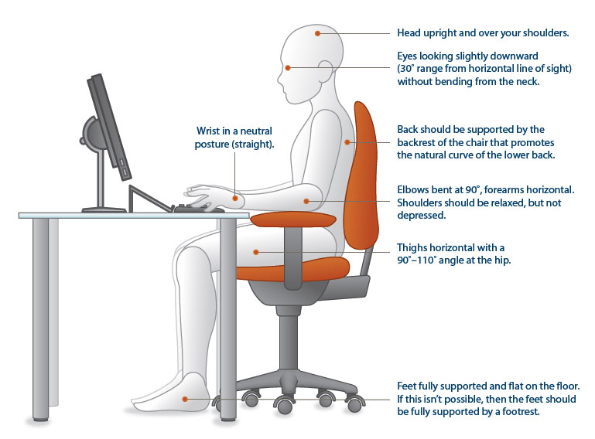
Simple measures using standard equipment that help to prevent RSI are:
- resting your feet flat on the floor, or on a footrest
- sitting central to the curve on any curved desk
- placing your screen at eye level and directly in front of you
- having your keyboard directly in front of you, with a space at the front of the desk to rest your wrists when you are not typing
- positioning your mouse as close to you as possible so you can use it with your wrist straight, avoiding awkward bending
- using a ‘compact’ keyboard without a number pad (if you do not do much number work) so that the mouse can be brought in closer still
- avoiding reflections from overhead lighting and sunlight
- using a document holder, to avoid bending your neck – position this centrally (with your monitor to the side) to also avoid twisting (if you tend to look at documents more than the screen)
- touch typing, to spread the load
- using predictive text and auto-correct features, to reduce keystrokes
- learning common keyboard shortcuts, to reduce the use of the mouse
- slowing your mouse down, to reduce muscle tension.
See the AbilityNet factsheet on Workstation ergonomics for more detailed advice on how best to achieve a safe, comfortable and productive workstation.

What other aids can help prevent RSI?
Apart from the adjustments you can make to standard input devices, various non-standard keyboards and mice are available that can improve the positioning of your hands and wrist – thereby reducing strain.
Possible options include:
- ergonomic keyboard, to aid touch typing (with a split between the keys operated by each hand)
- separate numeric keypad
- palm and wrist supports
- ergonomic mouse (which requires less gripping between your thumb and little finger)
- vertical mouse (which avoids having to twist your wrist to move the mouse on a horizontal surface)
- bar mouse (which avoids any gripping)
- trackball mouse (which also avoids any gripping).
The AbilityNet information sheet on Keyboard and mouse alternatives provide more detailed information on a wide range of alternative devices and options.
Alternatively, voice recognition software can be used for dictating text and for starting and controlling programs through spoken commands. Further information is available in the AbilityNet factsheet on Controlling the computer with your voice.
If you are getting symptoms in your dominant hand, it is not advisable to switch mouse use to your other hand. It is not so strong and could well soon display similar difficulties. Learning keystroke alternatives to limit mouse use is a preferable strategy, combined with early assistance from a good physiotherapist.

What about laptops, tablets and smartphones?
The main problem with laptops is that the keyboard is attached to the screen, this has a tendency to create a poor posture. To reduce such risks when working with a laptop for sustained periods, a good practice is to:
- use a separate keyboard, screen and mouse
- place your laptop on a raiser (so the screen can be raised as close to eye-level as possible)
- If using neither an external keyboard or mouse (not recommended for long periods of work), make sure that the laptop is on a stable base and not your lap
- take regular short breaks to relieve upper body tension
- sit up straight with your back supported.

Useful links and resources

Health and Safety Executive (HSE)
The Health and Safety Executive (HSE) is the national independent watchdog for work-related health, safety and illness. Its main aim is to secure the health, safety and welfare of people at work and protect others from risks to health and safety from work activity.
The HSE also plays a major role in producing advice on health and safety issues, and guidance on relevant legislation. The role of enforcement is split between HSE and local authorities depending on the business sector.
The following publications most relevant to managing RSI can be downloaded from the HSE website under (Upper Limb Disorders www.hse.gov.uk/a-z/u.htm#uld

The institution of Occupational Safety and Health (IOSH)
IOSH is the chartered body for health and safety professionals and a world leader in health and safety training. The IOSH OH Toolkit provides information, guidance and training materials on a wide range of conditions, including upper limb disorders, to help you tackle occupational health problems.
www.iosh.co.uk/Books-and-resources/Our-OH-toolkit.aspx

NHS Choices
NHS Choices is a reliable source of medical information on the symptoms, causes, diagnosis, treatment and prevention of repetitive strain injury.
Get more information at:
www.nhs.uk/Conditions/Repetitive-strain-injury/Pages/Introduction.aspx
RSI Action
RSI Action is a national charity that aims to facilitate:
- the prevention of the conditions known collectively as repetitive strain injuries
- the relief of sickness, hardship and distress amongst those suffering within the UK from RSI conditions.
- Get more information at www.rsiaction.org.uk

How can AbilityNet help you?
AbilityNet is a leading authority on accessibility and assistive technologies. We can assist individuals, charities and employers by providing:
- advice and information
- workplace assessments
- consultancy services.

My Computer My Way
My Computer My Way is a free, interactive tool developed by AbilityNet that makes any computer, tablet and smartphone easier to use.
It can help you ensure that your equipment is set up the best way possible to suit your particular needs. It covers all the accessibility features built into your computer, laptop, Chromebook, tablet or smartphone, and all the major operating systems – Windows, MacOS, iOS, Chrome OS and Android.
My Computer My Way shows you how to adjust your computer to assist with:
- vision – help seeing your screen
- hearing – help with sounds and audio
- motor – help with your keyboard and mouse
- cognitive – help with reading, spelling and understanding
You can use it for free at www.mycomputermyway.com

Workplace Assessment Service
When it comes to computing solutions, one size does not fit all. We believe that each case is unique and that individual attention is vital. Our Workplace Assessment Service integrates personal, technical and organisational considerations to arrive at sound and realistic suggestions, documented in a report.
To find out more about AbilityNet’s Workplace Assessment Service, please visit www.abilitynet.org.uk/workplace or call 01926 465 247.

Consultancy services
Our expert consultants are also available to assist employers who wish to take a broad, longer-term view in designing computer systems and associated work processes. Our experience and expertise can help you to achieve safe, healthy and productive working procedures.
To find out more about AbilityNet’s consultancy services, call 01962 465 247 or email sales@abilitynet.org.uk

DSA / Student assessments
If you have a disability and are in higher or further education, you may qualify for a Disabled Students Allowance (DSA). If you are eligible you will receive a free assessment and may qualify for a grant towards any adjustments that you might require. This could help with the costs of buying a new computer or any other specialist equipment you might need.
For information, please visit www.abilitynet.org.uk/dsa or call 01926 464 095.

About AbilityNet
AbilityNet is the national charity that supports people with any disability, of any age. Our specialist services help disabled people to use computers and the internet to improve their lives, whether at work, at home or in education. We offer:
- free advice and information
- accessibility services
- DSA/student assessments
- workplace assessments
- IT help at home
- IT volunteers.

Support us
Visit www.abilitynet.org.uk/donate to learn how you can support our work.

Contact us
- Telephone 0800 269 545
- Email enquiries@abilitynet.org.uk
- Web: www.abilitynet.org.uk
We are always keen to help share knowledge about accessibility and assistive technology. If you have any questions about how you may use the contents of this factsheet, please contact us at AbilityNet and we will do all we can to help.

Copyright information
This factsheet is licensed by AbilityNet under the Creative Commons Attribution-NonCommercial-ShareAlike 3.0 Unported License. View a copy of this license at creativecommons.org/licenses/by-nc-sa/3.0/

