AbilityNet Factsheet – April 2019
Keyboard and mouse alternatives and adaptations

Standard keyboards and mice are functional ways of interacting with your computer and increasingly other devices like tablets. However, these standard devices can pose difficulties for many people – especially users with physical, sensory, or cognitive challenges – and there are lots of other options available.

This factsheet provides details of some of the alternative keyboard, mouse and other pointing devices available. It also gives information on adaptations you can make to standard keyboards and mice. There are so many choices and variations, we cannot cover every single piece of equipment in this factsheet.
Please call our free helpline on 0800 269 545 or email us at enquiries@abilitynet.org.uk if you require more detailed information.

Contents
1. A note on ergonomics 3
2. Wired, Wireless, Bluetooth? 3
3. Keyboard alternatives 3
4. Typing without a keyboard 6
5. Mouse alternatives 7
6. Gaming controllers 10
7. Other equipment 10
8. Useful Contacts 11
9. How can AbilityNet help you? 11
10. About AbilityNet 12

A note on ergonomics
Being physically comfortable when using your technology is extremely important and extends beyond having a keyboard or mouse that is comfortable to use. Poor-posture, over-stretching or discomfort can result in aggravating existing conditions or in developing longer-term issues such as Repetitive Strain injuries (RSI’s). Good posture and comfortable working is important for everyone and finding something that works for you is obviously more important in preventing problems than in reaction to them.

Wired, Wireless, Bluetooth?
When it comes to things like keyboards and mice (peripherals) wireless normally means Bluetooth and most computers, laptops and phones have Bluetooth built-in. Some keyboards and mice may have their own receiver (called a ‘dongle’) that plugs in to a USB port on your computer in order to connect, others will need to be ‘paired’ (instructions for this will be included with the product). Although Bluetooth keyboards and mice will need batteries (or have rechargeable batteries built-in) they will often last for many months and will give you plenty of warning when they need charging or replacing.

Keyboard alternatives
The standard computer keyboard is designed to be used with two hands and has a number pad on the right-hand side, which obviously favours right-handed people.
Alternatives to the standard keyboard include:
- ergonomic keyboards
- smaller, compact keyboards
- separate numeric keypads
- keyboards with larger keys
- high-contrast keyboards
- early learning keyboards
- more specialist keyboards – braille, chording and expanded devices
- typing without a keyboard

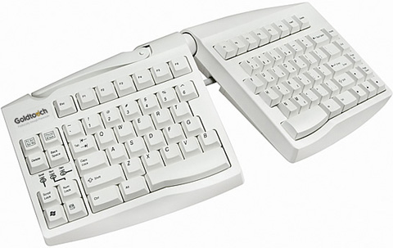
Ergonomic keyboards
Ergonomic keyboards are designed to promote a better typing position for your hands and wrists and therefore reduce the chance of strains and discomfort that can ultimately lead to significant issues such as Repetitive Strain Injuries (RSI). Ergonomic keyboards ‘split’ the keyboard in two, placing each half on a curve so your arms are at a more comfortable, relaxed angle when typing.

Some ergonomic keyboards are on a fixed curve, on others, the two halves are hinged in the middle so the angle can be adjusted, and some the two halves are completely separate and only joined by a connecting wire.

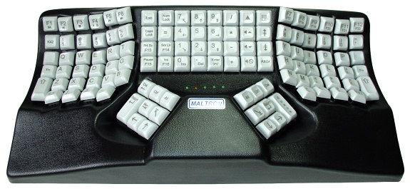
More contoured are a further development of the split concept. These place the finger keys into two cupped depressions at shoulder width, with function keys set in-between for use with the thumbs.

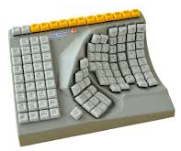
These fully ergonomic keyboards require very little movement of the arms and wrists and are designed to reduce the risk of RSI. Similar keyboards (with a non-QWERTY layout) are also available for single-handed users – for either left- or right-handed use.

Smaller, compact keyboards
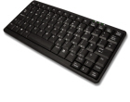
Compact keyboards, as their name suggests, are smaller keyboards. The actual key sizes are quite similar to a standard laptop keyboard and, like a laptop, space is saved by removing the number pad (this can be separate, or some have one that slides out when needed).
A compact keyboard frees-up desk space and allows you to bring your mouse (or other things you use) closer to your centreline, which helps to reduce the chance of strains by over-extending.
As they are smaller, compact keyboards can fit more easily between the arms of a wheelchair and are often more comfortable to use for single-handed users.

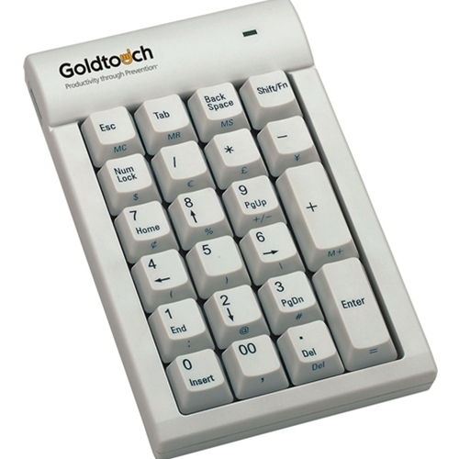
Numeric keypads
A separate number pad is normally used with a compact keyboard and can be moved out of the way when not needed. It can also be placed either side of the keyboard, which can be helpful for left-handed users.

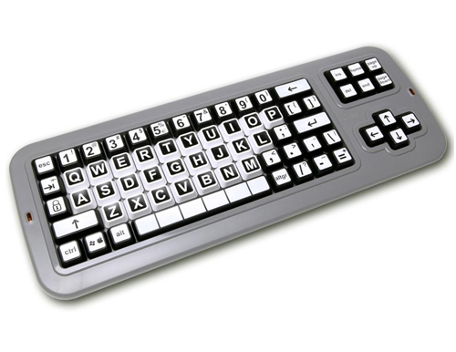

Keyboards with larger keys
Keyboards with larger keys (like BigKeys and Jumbo Keyboards) make it easier to locate keys and provide a bigger ‘target area’. Options are available with upper- or lower-case layouts

Keyboards with more visible keys
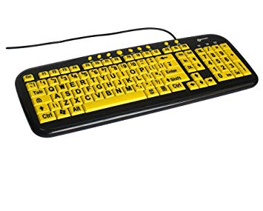
High visibility keyboards use high-contrast colours to make the keys easier to locate. There are many different colour combinations with either the keys or the letters as the ‘stand-out’ colour (eg. yellow on black, black on yellow, black on white, white on black)

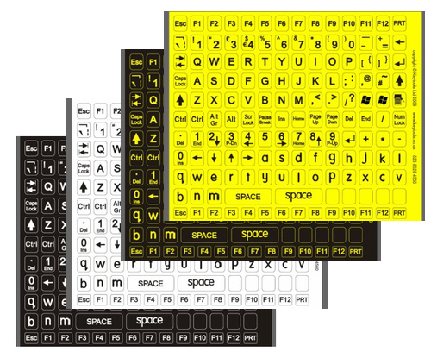
Modifying the keyboard appearance
Rather than buying a high-contrast keyboard, high contrast stickers are available. These are stuck on top of the keys on your existing keyboard.

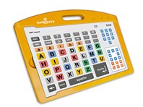
Other specialist keyboards
Helpikeys is a customisable adaptive keyboard for people with learning and motor difficulties. It is also beneficial for people with visual or cognitive challenges. In addition to five available overlays, the keyboard can also be programmed to store five further personalised layouts.

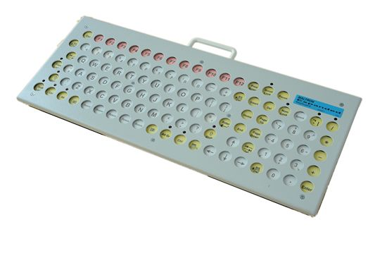
The Maltron expanded keyboard is designed to assist people with cerebral palsy and to provide better access for physically disabled and visually impaired users. A metal keyguard helps to prevent accidental key presses and protects against any impact damage.

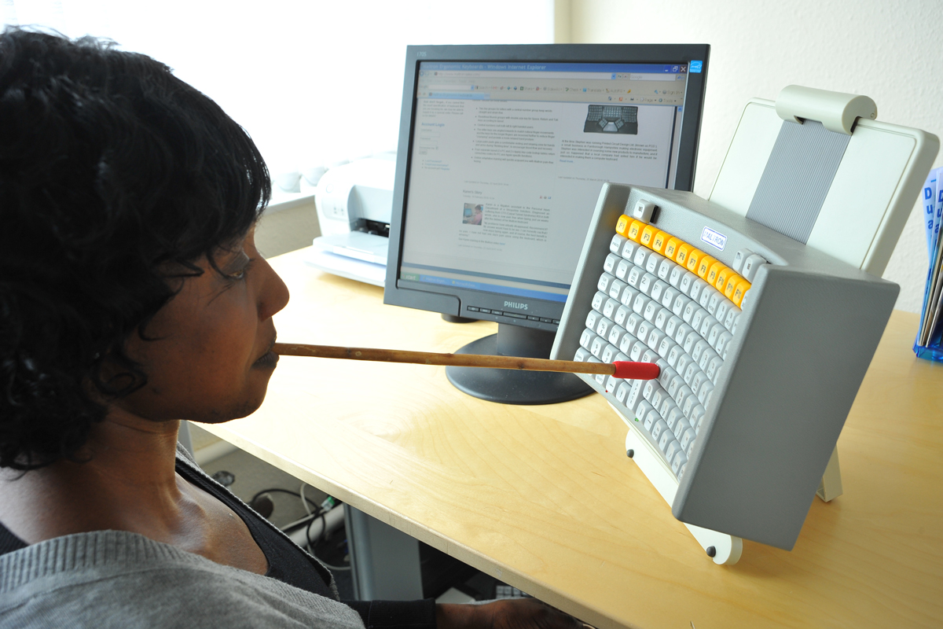
Maltron also produce a keyboard for people with no use of their hands. The head /mouth stick keyboard has a shape and layout to match natural head movement and minimise the amount of movement needed from the stick.

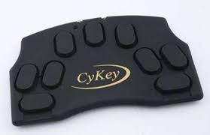
Chording keyboards (like the Cykey shown here) only have a few keys that you press in combination (like chords on a piano) to generate letters, numbers and other keys. They work well for one-handed users with independent movement in their fingers.

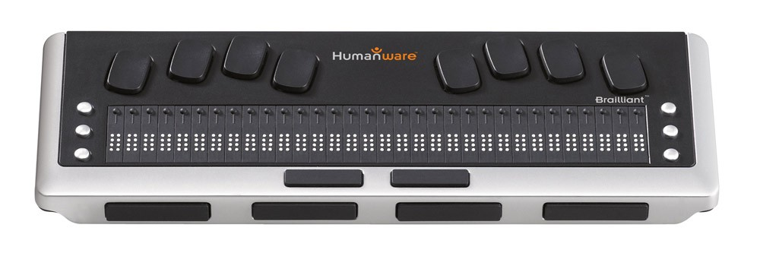
Braille displays serve a dual function and enable you to both enter text and control your computer, and also to read documents, emails and web pages etc, using a tactile Braille display.

Keyguards
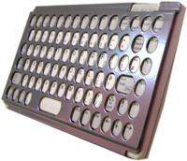
Keyguards are rigid plates with holes designed to work with specific keyboards. The holes are positioned over each key and significantly reduce the chance of accidental keypresses. The guard also allows you to rest your hands and arms on the guard without pressing any of the keys. Guards can be removed and fitted for use only when required. It is usually easier to purchase a keyboard and guard together rather than trying to get a guard to fit a specific keyboard.

For more information, see Making your keyboard easier to use

A note on touch-typing
Whether you are using a physical keyboard or touchscreen we’re keen to stress the value of learning touch-typing skills for which there are many training packages available.

For adults we recommend:
- English Type www.englishtype.com
- KAZ kaz-type.com
For children we recommend:
- Nessy Fingers www.nessy.com/uk/product/nessy-fingers
- Dance Mat Typing www.bbc.com/bitesize/articles/z3c6tfr

Typing without a keyboard
You do not have to use a physical keyboard to control or type on your computer, tablet or smartphone. Possible alternatives include using:
- an on-screen keyboard
- voice recognition (speech-to-text)
- an eye tracking system
- a switch
- a head tracking system
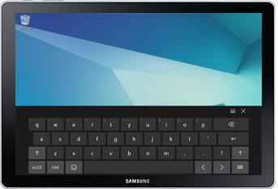
On-screen keyboards are the way most people now type on tablets and smartphones but are also standard features on most operating systems. Letters can be selected using a touchscreen, a mouse, a switch, or a joystick.

For more information, see: Using on-screen keyboards

Voice recognition is a practical way of controlling your computer and a very efficient means of getting information down. Voice recognition (speech-to-text or dictation) is useful for people can find typing difficult, painful or impossible, but it can also by-pass issues with things like spelling or grammar and so can be a great help to people with learning differences like dyslexia.

For more information on voice recognition see My Computer My Way; Talking to your device. We also have a factsheet; Controlling a computer, tablet or smartphone with your voice.

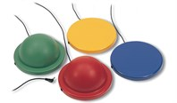
A switch input is a button which, when activated, sends a signal to the computer. The switch can also be replaced with a sensor that detects an eye blink, a puff down a tube or any reliable body movement. An on-screen keyboard, word or pictogram board is used to highlight rows, columns or groups, gradually narrowing-down a selection with each activation of the switch until the desired word or letter is the last option left.

Switches work well with cause and effect programmes that require simple choices but are in no means limited to this; skilled operators have few restrictions to what they can do.

Eye tracking and head tracking systems tend to operate an onscreen keyboard using the mouse so are included in the mouse section below.

Mouse alternatives
There are many different types of mice available and it is important to choose one that fits the hand well and feels comfortable and easy to use. Often it takes a little while to get used to using a new type of mouse and can feel a little clumsy at first.

Alternatives to the standard mouse

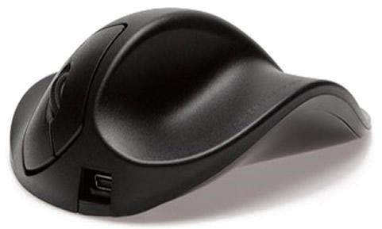 | Ergonomic mice often come in left- and right-handed orientations and in different sizes, to ensure the mouse fits comfortably.
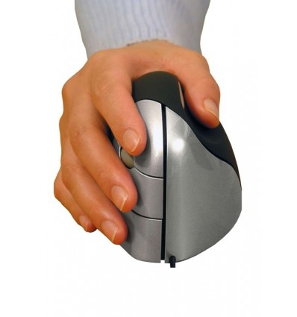 | Vertical mice realigning the wrist to a more natural ‘handshake’ position, transferring movement onto the more powerful shoulder muscles.
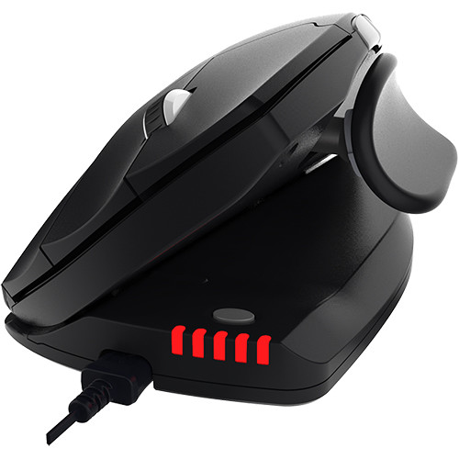 | Adjustable Ergonomic mice are hinged along one side and allow for the mouse to alternate between a flatter more traditional position and the vertical, this encourages a variable wrist position and can help move from a normal mouse to a vertical.
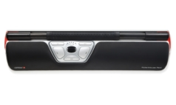 | Bar mice are positioned directly in front of the keyboard and have a ‘bar’ that slides left and right and rolls for up and down movement. The position of the bar allows it to be operated with your thumbs and keeps your hands on or close to the keyboard.
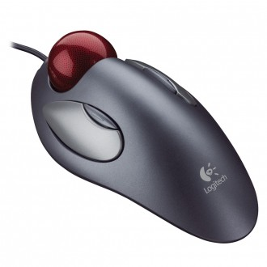 | Trackball, trackerball or rollerball mice remain stationary with the cursor controlled by rolling a ball with thumb, fingers or palm. This means there is little to no wrist movement.
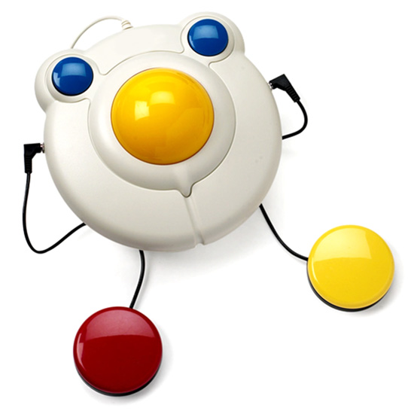 | Larger trackball mice are easy to use and may be particularly helpful for users who lack fine motor skills, including people with learning difficulties, tremors or arthritis. Also, like the BIGtrack mouse (with switches) shown here, they can be strong and are often suitable for being operated by elbows or feet.

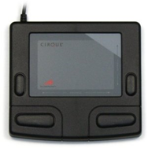 | Touchpads (or trackpads) are stationary pads operated by sliding (or swiping) your finger(s) across the surface; clicking can be done with buttons or by downwards pressure / tapping lightly on the surface.
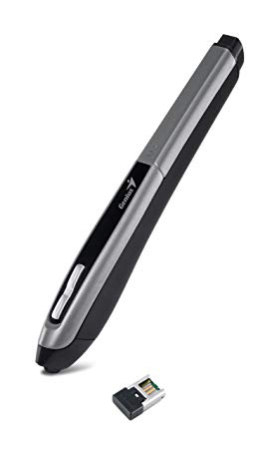 | Pen mice are held in the hand like a pen. They tend to be quite ‘chunky’; a similar size to a marker pen. Left and right click buttons are vertical on the pen shaft.
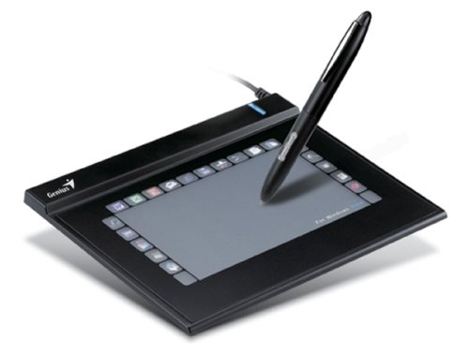 | Graphics tablets these require a specialist tablet to write on, but the pens they use are more pen-like than pen mice and generally more comfortable to hold.  Graphics tablets tend to be more geared towards design than ergonomics.  Many tablet manufacturers are beginning to produce a pen or ‘stylus’ as another means of interacting with the tablet and will allow you to make handwritten notes.

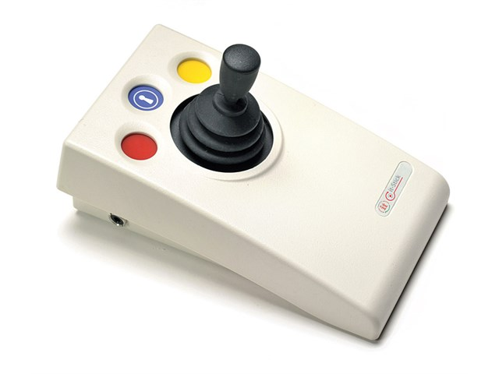
Joysticks work in a similar manner to the controls on an electric wheelchair, with the joystick position determining the direction (and speed) of the mouse pointer.
Additional buttons on the joystick can operate left, right and double clicks, as well as other common shortcuts such as cut and paste.

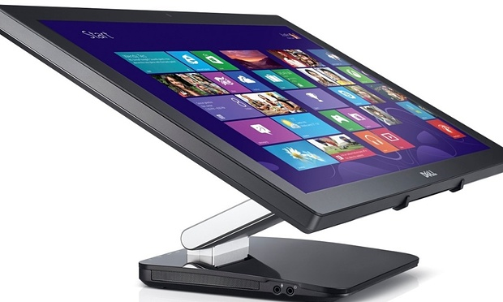
Touchscreens use sensors in the screen to track movement and selections and are a very direct and method of interacting with your device. Tablets and smartphones use touchscreens as well as many laptops. Touchscreen monitors are also available for use with desktop computers.

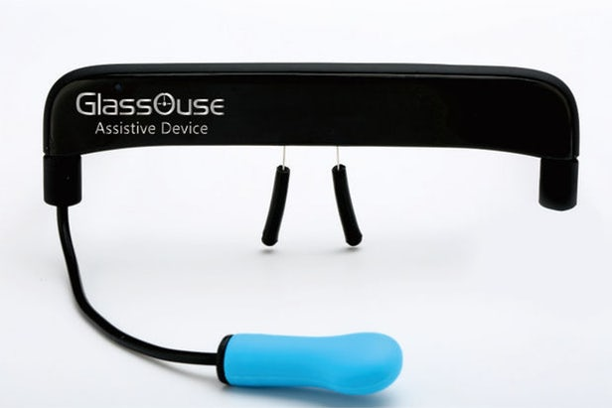
Head movement tracking uses head movement to control the cursor. This can be done with a wearable like the headset in the picture or using a camera. With head movement tracking, he cursor is ‘driven’ around the screen in the same way as using a joystick. elections are made using a switch that can be controlled by a puff or bite (the blue bulb in the picture).
Eye tracking systems track eye movement, using it to plot the position of the cursor on the screen. Dwelling on a location triggers a ‘click’. This can be used to control programmes as well as to type when used with the on-screen keyboard.

Tracking eye movement means that the cursor does not need to be driven around the screen and so is typically much faster than head movement tracking. Although initially designed for use by people with very limited movement, eye tracking hardware and software is now relatively inexpensive and can present an interesting alternative for people experiencing temporary or situational disabilities; for example, a parent could hold their baby and still be able to interact with their computer.

Foot mouse systems are typically designed to use both feet. One foot controls the cursor using a slip-on puck on a mat. The other foot controls switches, often with single and double click or other options controlled by separate buttons.

Gaming controllers
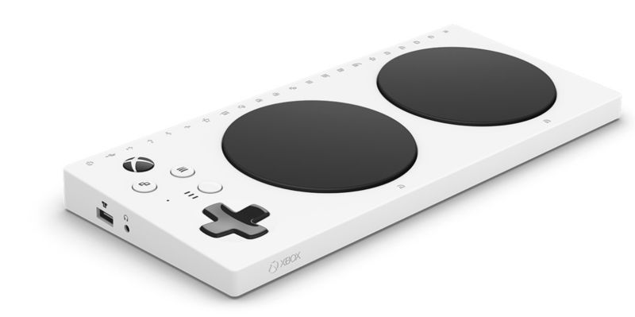
There are several accessible gaming controllers available such as Microsoft’s Xbox adaptive controller. The controller inputs can be ‘mapped’ to a person’s preferences and used alongside the standard controller allowing disabled and non-disabled gamers to compete at the same level.

Other equipment
It is important to have your screen positioned at a comfortable level to minimise bad posture and the risk of injury. We recommend your screen is directly in front of you so you do not have to twist your body, and should be approximately an arms-length away with the top of the screen roughly level with your eyes.

Other equipment such as monitor-raisers and monitor arms allow you to raise the height of a screen. Laptop stands can also be helpful but may require you have a separate keyboard and mouse.

Tablets can also be mounted on flexible arms viewing comfort, but this is not always practical, as they are normally controlled with the touchscreen.

Lap trays and other supports
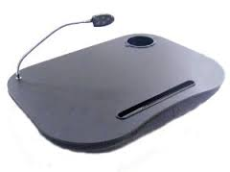
A lap tray can allow you to use a tablet or laptop comfortably on your lap and provides a flat, stable surface on one side and a beanbag on the underside that moulds to the shape of your legs.

Arm or wrist pads placed in front of the keyboard can be helpful when resting from typing and can help to reduce discomfort and strain. You can also get wrist ‘donuts’ that are worn around the wrists like bracelets and provide support wherever you are working.

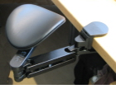
Articulating wrist supports clamp to the table top and are a more specialist support typically in instances where there are difficulties supporting the weight of the arms.

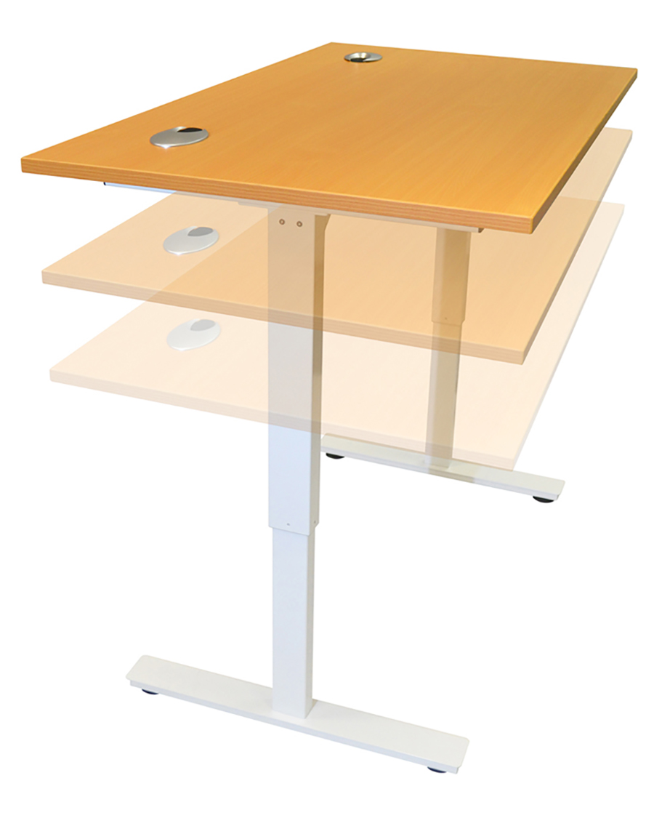
Desks
Sit stand desks can be adjusted according to height and are designed to encourage movement and allow people to working sitting or standing. They are a simple accommodation for people of different heights as well as wheelchair users. Desks are available in a manual hand-cranked or electronic version as well as smaller clip-on units that fix to an existing desk to.

Useful Contacts
There are many suppliers and manufacturers of ergonomic equipment; below are a list of companies with specialist knowledge who may be able to offer additional advice if needed:

- Hands-free computing: www.hands-free.co.uk/
- Posturite: www.posturite.co.uk/
- Contour: contour-design.co.uk/
- Evoluent: evoluent.com/
- Tobii (Eye Gaze): www.tobii.com/group/about/this-is-eye-tracking/
- Glassouse (Head tracking): glassouse.com/
- Microsoft (Gaming Controller): www.xbox.com/en-GB/xbox-one/accessories/controllers/xbox-adaptive-controller

How can AbilityNet help you?
AbilityNet is a leading authority on accessibility and assistive technologies. We can assist individuals, charities and employers by providing:
- advice and information
- workplace assessments
- consultancy services
- DSA / student assessments

My Computer My Way
My Computer My Way is a free, interactive tool developed by AbilityNet that makes any computer, tablet and smartphone easier to use. It can help you ensure that your equipment is set up the best way possible to suit your particular needs. It covers all the accessibility features built into your computer, laptop, Chromebook, tablet or smartphone, and all the major operating systems – Windows, MacOS, iOS, Chrome OS and Android.

My Computer My Way shows you how to adjust your computer to assist with:
- vision – help seeing your screen
- hearing – help with sounds and audio
- motor – help with your keyboard and mouse
- cognitive – help with reading, spelling and understanding
You can use it for free at mcmw.abilitynet.org.uk

Workplace Assessment Service
When it comes to technology solutions, one size does not fit all. We believe that each case is unique and that individual attention is vital. Our Workplace Assessment Service integrates personal, technical and organisational considerations to arrive at sound and realistic suggestions, documented in a report.
To find out more about AbilityNet’s Workplace Assessment Service, please visit www.abilitynet.org.uk/workplace or call 01926 465 247.

Consultancy services
Our expert consultants are also available to assist employers who wish to take a broad, longer-term view in designing computer systems and associated work processes. Our experience and expertise can help you to achieve safe, healthy and productive working procedures.
To find out more about AbilityNet’s consultancy services, call 01962 465 247 or email sales@abilitynet.org.uk

DSA / Student assessments
If you have a disability and are in higher or further education, you may qualify for a Disabled Students Allowance (DSA). If you are eligible you will receive a free assessment and may qualify for a grant towards any adjustments that you might require. This could help with the costs of buying a new computer or any other specialist equipment you might need. For information, please visit www.abilitynet.org.uk/dsa or call 01926 464 095.

About AbilityNet
AbilityNet is the national charity that supports people with any disability, of any age. Our specialist services help disabled people to use computers and the internet to improve their lives, whether at work, at home or in education. We offer:
- free advice and information
- accessibility services
- DSA/student assessments
- workplace assessments
- IT help at home
- IT volunteers.

Support us
Visit www.abilitynet.org.uk/donate to learn how you can support our work.

Contact us
- Telephone 0800 269 545
- Email enquiries@abilitynet.org.uk
- Web: www.abilitynet.org.uk
We are always keen to help share knowledge about accessibility and assistive technology. If you have any questions about how you may use the contents of this factsheet, please contact us at AbilityNet and we will do all we can to help.

Copyright information
This factsheet is licensed by AbilityNet under the Creative Commons Attribution-NonCommercial-ShareAlike 3.0 Unported License. View a copy of this license at creativecommons.org/licenses/by-nc-sa/3.0/

