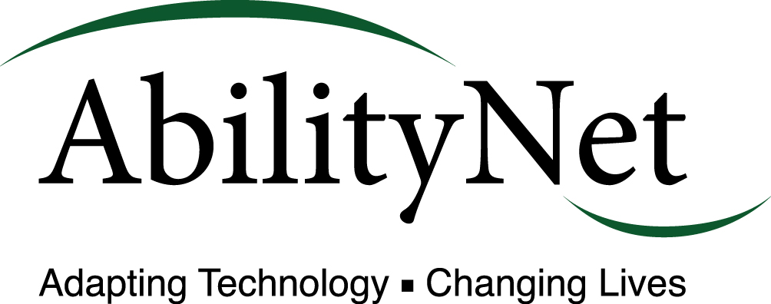

Guide to Getting Online
Researched and written in partnership with Ofcom Accredited broadband deals comparison site www.cable.co.uk

If you don’t have broadband, have never had to decide between a 3G or 4G connection for your mobile, or just not had much experience of going online, it can be difficult knowing where to start. That’s why we’ve produced this jargon-free beginners guide to connecting to the internet.

What is broadband?
Broadband is currently the fastest way of connecting your desktop computer, laptop, smartphone, tablet or games console to the internet. Using a network of either copper or fibre optic cables (or a combination of the two), broadband replaced the older dial-up method of getting online. Unlike its predecessor, broadband doesn’t tie up your landline or mean your number would be engaged while you were connected to the internet.
You can access broadband over your phone line (but still make calls at the same time), via cable or satellite. This connection to the world wide web allows you to draw down data from (download) or send data to (upload) a massive network of interconnected computers and the servers that help them communicate with one another.
Everything you do online uses data, whether it’s visiting a website, sending an email, watching a video or listening to music. As you’ll see, the speed at which you can send or receive this data can make a big difference to your experience online.

Why speeds matter
Broadband speeds are measured in megabits per second (often presented as Mbps). Like the speedometer on a car, the higher the number, the faster your connection will be. According to telecoms regulator Ofcom, the average broadband speed in the UK is around 12Mbps, but internet service providers (ISPs) do offer a range of optimum speeds that exceed this.
The fastest widely available broadband in the country offers up to 152Mbps via a fibre optic connection, although a variety of factors can impact on the actual speed you’ll get on a day to day basis. You’ll find that the distance from your local telephone exchange, the number of people who are simultaneously connecting to the same network as you and the age of the technology your broadband uses can all either help or hinder your speed.

Different types of broadband
Here are the most common types of broadband connection available in the UK. You’ll find that whichever option you choose, you’ll be able to select either unlimited monthly data deals or a cheaper but more limited allowance.

ADSL
Standing for Asymmetric Digital Subscriber Line, this complicated name refers to how downloads get priority over uploads (hence asymmetric rather than symmetric). This unbalance is because ISPs believe users are more likely to download data from rather than upload data to the internet. Carried on traditional copper telephone lines, ADSL is available to approximately to 99.9% of homes in the UK.
Data can slow down over copper cables the further it travels, so your distance from the nearest telephone exchange can negatively impact on your speed.

Fibre broadband
Fibre optic technology allows data to move at a much faster rate than on ADSL connections, with little or no slowdown over long distances. Fibre optic connections are generally newer than the already established copper phone network, but the downside of this is that some parts of the country are still waiting for ISPs to bring fibre to their local area.
Another complication is that most fibre broadband connections will use some degree of copper cabling along its journey (most often between your nearest green telecoms cabinet and your home), so while your data can race along fibre, it can slow down considerably on the closing copper stretch.

Satellite broadband
If you’re in an area that can’t yet receive fibre, satellite broadband could be the answer. All you need is a receiver and a clear line of sight to the sky, with your data bounced to and from your home via a satellite connection.

Mobile broadband
Should you find that you’re in an area with good mobile coverage, you could also explore mobile broadband options. Using either 3G or 4G connections on your mobile phone (referring to the third and fourth generations of mobile technology) you can get online on the move.
This same technology also powers mobile broadband dongles (generally USB sticks that you can plug into a PC or laptop) and portable Wi-Fi technology which generates a broadband connection – as long as you’ve got a strong enough mobile signal.

How can I get broadband?
Your first step for finding out your broadband options is running a postcode based availability checker (ideally using an Ofcom accredited website to ensure you’re getting impartial, up to date and accurate information).
This will show the range of providers in your area, the different plans available and how much you’ll pay each month. Unfortunately, all but one of the major broadband providers in the UK requires you to have a landline, so you’ll also have to factor in the cost of line rental if you don’t already have a home phone.

What broadband deal is right for me?
The ideal broadband package for you depends on how you’re planning on using your internet connection. If you’re only likely to pop online infrequently to visit a selection of websites or send the odd email, then you won’t need to opt for a superfast connection or an unlimited data allowance.
If you’re part of a large family, want to connect multiple devices to the internet at the same time, need to download or upload data quickly or are planning on streaming lots of video or music via your broadband connection, then one of the faster fibre optic connections could be right for you.
Fast upload and download speeds are also important if you’re planning on making lots of voice or video calls to friends or family using your desktop PC, laptop or tablet. The faster your connection, the smoother your call should be.
The perfect package is likely to be determined by a combination of what’s available where you are, how much you’re looking to pay each month, how fast you need it to be the amount of data you’re likely to use each month.

Researched and written in partnership with Ofcom Accredited broadband deals comparison site www.cable.co.uk

