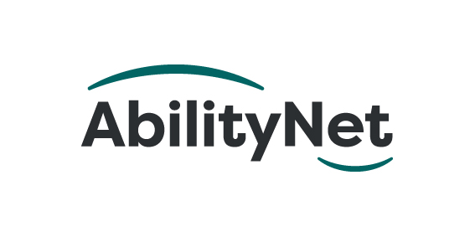

Learning together
How AbilityNet delivered free tech support to people with learning disabilities through the Digital Lifeline scheme

September 2021

Table of Contents
1. Executive Summary 3
2. Introduction: Covid-19 and the digital divide 4
2.1. A digital world accessible to all 4
2.2. Covid-19: exposing the digital divide 4
2.3. Digital Lifeline: an emergency response 4
2.4. Measuring our impact 5
We were keen to measure our impact in supporting people with learning disabilities. This report, will inform: 5
3. Our role in Digital Lifeline 6
3.1. AbilityNet’s role supporting community partners 6
3.2. AbilityNet’s role supporting individuals 6
4. Understanding needs and barriers 7
4.1. Accessibility barriers for people with learning disabilities 7
5. Individuals’ aims and goals 8
6. Key findings: adjustments and impact 9
6.1. Commonly recommended adjustments 9
6.2. Hardware adjustments 9
7. Key findings: impact on daily life 10
7.1. Keeping people connected during Covid-19 10
7.2. Staying well during Covid-19 10
7.3. Impact on education and learning 10
7.4. Impact on work and employment 11
7.5. Online shopping and banking impacts 11
8. Improving digital skills and confidence 12
8.1. Building digital confidence 12
8.2. Performance of peripherals 13
8.3. Impact on community partners 13
9. Challenges and recommendations 14
9.1. Short timeframe for delivery 14
9.2. Communication and contact 14
9.3. Appetite for adaptations versus adoption 14
10. Useful Resources and References 15

Executive Summary
For disabled people, Covid-19 hit especially hard; more likely to be shielding and more likely to be furloughed. While the rest of us turned to technology to maintain social contact during physical distancing, many disabled people lacked the equipment and digital skills for online.
For people with learning disabilities, Covid-19 exaggerated inequalities, prompting the UK Government to launch Digital Lifeline as an emergency response.
AbilityNet was proud to participate in the scheme alongside other charities, designed to get free tablets to thousands of people with learning disabilities. Our role was to provide free specialist support to community groups and individuals to adapt the tablets to be easier to use.
It’s been a learning experience for us all.
What have we learned from Digital Lifeline?
This Impact report captures some of our learnings. For example, we've learned about what people with learning disabilities aspire to do with technology and the barriers they face when using a device.
What we discovered was that simple interventions could make a big difference. Peripherals – notably robust cases – can inspire confidence. At the same time, the right app can make it easier for people to use services such as messaging. Digital skills and accessible technology lead to improved wellbeing, stronger relationships can grow independence, and people’s capacity to learn.
We know the value of working in partnership. Community partners play a vital role as champions of accessible technology. Partners would benefit from longer-term help and guidance to develop their digital confidence. Similarly, we've deepened our relationship with Good Things Foundation and other partners.
Digital Lifeline provides a springboard for change. We are committed to growing the skills and confidence of people with learning disabilities to maintain confidence and embrace new tasks such as digital health.
Together we can make the digital world accessible for all.
Amy Low, Service Delivery Director, AbilityNet

Introduction: Covid-19 and the digital divide

A digital world accessible to all
AbilityNet’s mission is a digital world accessible to all. We are a pan-disability charity that supports individuals at home, at work and in education.
We offer free information and community-based support with technology from desktop computers to smartphones throughout the UK. Our 300+ vetted volunteers provide support remotely, by phone and video and – as Covid-19 lockdown restrictions ease – we'll return to offering in-person support.
Our support has never been more needed. In 2020, the year Covid-19 hit, we helped 6,878 individuals27% more than the previous year.

"Concerns about the digital divide have been particularly acute during the COVID-19 pandemic as the internet and digital devices have played a vital role.”

Covid-19: exposing the digital divide
Never has technology been more needed than during Covid-19. Even pre-pandemic 4x as many disabled as non-disabled people in England felt lonely “often or always”.
We know that digital exclusion is most prevalent among elderly and disabled people. Covid hit hard, with 62% of disabled people report that Covid-19 affected their wellbeing and 31% of disabled people struggling to get groceries, medicine, and essentials due to the pandemic .

Digital Lifeline: an emergency response
For the learning disabled, the pandemic intensified existing inequalities in everything from access to healthcare to employment. In response, the government launched Digital Lifeline, a £2.5 million Department for Culture Media, and Sport funded emergency response project.
Delivered between March and July 2021, Digital Lifeline distributed 5,000 tablets to adults with learning disabilities in England at risk of digital exclusion and greater social isolation because of Covid-19.
Charities, including AbilityNet, stepped up to deliver the emergency response.
Good Things Foundation spearheaded Digital Lifeline in partnership with AbilityNet and Digital Unite. Together with Learning Disability England, the Voluntary Organisations Disability Group, self-advocates, and other disability inclusion organisations, the aim was to ease the pandemic’s negative impact through access to technology and by enhancing people’s digital skills.
We were delighted to bring our expertise in supporting disabled people through technology. Our specialist assessors and volunteers provided support to:
- Community partners who applied for devices on behalf of users
- People with learning disabilities who received a device
Our specialist assessors and volunteers assessed people's digital needs, recommended adaptations, and helped to implement changes to settings.

Measuring our impact

We were keen to measure our impact in supporting people with learning disabilities. This report, will inform:
- Government departments
- Digital inclusion specialists in the private, public, and voluntary sectors
- Community groups supporting people with a learning disability.
- People with learning disabilities and the paid and unpaid carers who support them.
We’ll use the information we’ve gathered to improve the support we offer to people with a learning disability and have identified a series of next steps.
Through Digital Lifeline, we have learned more about the technology needs of people with learning disabilities. Technology can empower people to do more – including staying connected to loved ones and exploring hobbies.
The report draws on the views of 971 people and 121 organisations.
We also conducted numerous follow-up calls and questionnaires towards the project’s end.
- Read on for more details of our findings

Our role in Digital Lifeline
Under Digital Lifeline, individuals couldn’t directly apply for a device; instead, community organisations with a role supporting people with learning disabilities could refer them for a tablet.
It was vital for us to support both these community partners and the individuals they support.

AbilityNet’s role supporting community partners
We supported 121 of the150 community organisations that received tablets for people with learning disabilities.
The community partners identified who would benefit from a tablet and our advanced individual assessment. We also delivered accessibility training to organisations and helped adjust accessibility settings, install specialist apps, and set up peripherals to make the tablets easier to use.
Of the 121 community partners we helped:
41 | Received direct support for beneficiaries:  - booking 371 assessments,  - and requesting further peripherals for 233 people
13 | Requested peripherals without assessment for a further 367 beneficiaries
92 | Attended a total of 213 training sessions
45 | Attended two or more training sessions  - some attended as many as ten sessions
43 | Benefitted from the help of 101 volunteer buddies

AbilityNet’s role supporting individuals
We provided digital accessibility training for community organisations supporting 2,978 people who received tablets, improving the experience for 54% of all Digital Lifeline beneficiaries. We directly contacted:
- 971 people with learning disabilities (including assessment, support and/or additional peripheral equipment)
- 371 of the 971 people received a full needs assessment.

Understanding needs and barriers
Our approach is to provide tailored, individual support, so it was essential to understand the needs and barriers of individuals.
After learning disabilities (91.6% identified as having a learning disability); the next highest need was "dexterity) (37.9%), with 25.5% citing mobility needs, perhaps explaining the high demand for peripherals.
More than half the people were assessed (58.8%) experienced several support needs and faced multiple barriers to digital access.

Learning disability | 91.6%
Dexterity | 37.9%
Memory | 29.5%
Mobility | 25.5%
Vision | 23.3%
Mental health | 20.1%
Hearing | 18.7%
Stamina | 7.6%

Accessibility barriers for people with learning disabilities
The most significant barriers to digital access were physical difficulties in typing text, understanding text and dexterity issues.
Most people (81.3%) faced two or more barriers.
Inputting text | 71.5%
Understanding text | 71%
Operating tablet | 60.7%
Remembering how to do things | 43.9%
Speaking to the tablet | 32.8%
Hearing content | 16%

“Our response was not one size fits all. Inclusion isn’t just about providing a device - there’s a death of knowledge about how to use technology.”
Community Relations Officer, Chris Grant.

Individuals’ aims and goals
Our assessments reflected the daily challenges learning disabled people face, from health inequalities to social isolation. People said their main aims related to wellbeing, relationships, and learning.
Goals related to work and finances were lower on wish lists, reflecting the small proportion of learning-disabled people in work and the existing challenges people experience in managing their money.

People we assessed told us what they wanted to use their devices for:

Wellbeing | 65.6%
Relationships | 59.3%
Education | 50.4%
Health | 11.1%
To obtain groceries, medications, or essentials | 4.6%
Work | 3.8%
Household finances

To achieve their broad social and learning aims, people said they wanted to use their devices in specific ways, including:

Video calling | 80.8%
Playing games, jigsaws and colouring | 73.2%
Watching TV | 70.5%
Listening to stories and podcasts | 50.1%
Using websearch (weather, news, facts) | 48.2%
Messaging friends or relatives | 26.8%
Joining social groups | 26.6%

Key findings: adjustments and impact
Tablets come with a variety of assistive technology (AT) built-in. Tech companies such as Apple and Google (Android) build features that can help everyone access the digital world.
So, what was most helpful to people with learning disabilities?

Commonly recommended adjustments
We recommended a range of adjustments. These included using predictive text and voice assistant functions, making it easier for people to input text. We've already seen from the barriers that inputting text was the biggest barrier.
We advised text-to-speech for those who had difficulties understanding text. For those with visual problems, we recommended magnification.
Shortcuts to success: Focus on Action Blocks
Apps can add functionality to a tablet. One that proved popular with the people we helped was Action Blocks. (Android).
The app enables you to place customised buttons on a tablet's Home screen, which act as shortcut buttons. You can configure them to do anything that Google Assistant can do, such as video call a friend.

Hardware adjustments
As well as recommending adjustments and apps, we advised on and ordered 2,354 pieces of peripheral equipment across the 971 beneficiaries. Recommended peripherals included robust cases and stands to solve dexterity issues and headphones and speakers to help with hearing problems.
We found that community organisations often lack awareness of accessibility-boosting possibilities. AbilityNet assessment team manager Teresa Loftus said:
"Peripheral items such as large high contrast keyboards or keyboards with guards received excellent responses. Peripheral items such as the high contrast keyboard and keyboard with guard have made a significant impact in helping people to type into their device.”

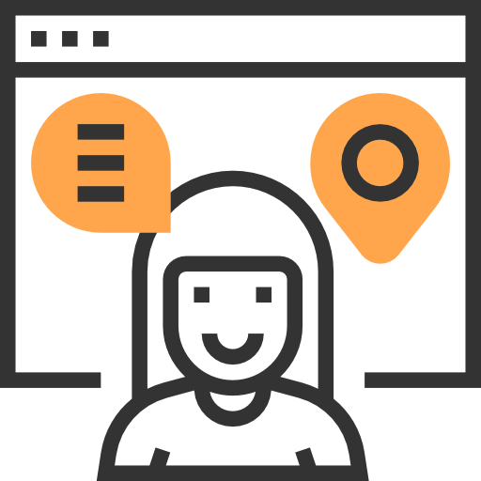
Key findings: impact on daily life
Scope’s Head of Digital Influencing Krissie Barrick points out that “Being locked out of the online world is the same as being locked out of the world.”
Access to the digital world, through Covid-19, has been vital for accessing essential services such as healthcare, goods and services, and maintaining relationships in a time of physical distancing.
We wanted to find out how people used their devices for everyday life.

Keeping people connected during Covid-19
Tablet recipients embraced the devices as a means of keeping in touch and expanding social activities. Tablet recipients felt more connected to friends and family (73%) and less lonely and isolated (79%).
Gameplay was popular – 90% used the tablet to play games. And 74% joined an online club, with 19% wanting to learn how to do this.

“It's had a good impact. It’s given me more independence. It’s allowed me to keep my interests and access them in a different way.”
Janet Groves, Digital Lifeline beneficiary, Worcestershire.

Social media use was a popular way to connect (72%). Messaging apps were also popular, with 49% of people using WhatsApp or Facebook Messenger and 36% wanting to learn how. Email was less commonly used.

Staying well during Covid-19
Of those who wanted to do so, 89% of people felt better able to manage their health and wellbeing. So, while only 5% of people had attended an online GP appointment, 52% wanted to learn how.
And 43% had attended a virtual class, with 29% wanting to in the future.

Impact on education and learning
Having a learning disability can make it more difficult for people to learn – often because conventional classrooms aren’t adapted to their specific needs.
Yet, Digital Lifeline recipients had a huge appetite and aptitude for learning. Of those already in education, 56% continued with courses; 31% reporting they had yet done so but wanted to.

It’s very good for jigsaws.”
Lillian Tellsdale, Digital Lifeline beneficiary, Cumbria.
As for finding courses online, 15% had done so, and 54% wanted to.
Beneficiaries also reported feeling more skilled for education or more able to participate in education (72%).

Impact on work and employment
The relatively small number of people using devices to look for jobs (17%) is in line with the low employment rate among learning disabled people. But there was a clear interest in online job hunting, with 33% of people reporting they wanted to know to do this.

Online shopping and banking impacts
50% of tablet users had used their device for online shopping, with a further 29% reporting that this was still a goal.
Few people were able to keep track of household finances online, reflecting the challenges people have managing money. Just 17% of people had used their tablet for online banking, although another 33% wanted to learn.

Improving digital skills and confidence
Our data reveals the importance of being able to adjust tablets to make them easier to use. Almost all (95%) said devices had been adapted to meet their needs – or that they wanted to make changes.
However, some people hadn’t set up our recommended accessibility settings, reflecting how specific changes require more time and support.
For example, 63% of people with vision problems said they did not use the recommended text-to-speech setting but wanted to learn how. Similarly, 60% of people with vision problems had not used speech-to-text but were keen on learning. 82% had not used the recommended reminders among those with memory issues but wanted to learn.

“It’s a very rewarding project and helps people with learning disabilities access the internet who wouldn’t be able to or think that they can’t do it.”
Claire Dougherty, library outreach project manager
Penrith Library

Building digital confidence
Much of our work focussed on growing people's confidence. We were delighted that 92% of people said their digital skills had improved, reflecting the vast positive impact of accessibility settings and adaptations.
- 97% were either aware of staying safe online or wanted to learn more
- 66% of people had successfully used internet browsers; 30% wanted to
The most popular app we recommended for those with dexterity issues was Action Blocks, with 59% using these and another 36% want to. Action blocks were also valuable for those with communication issues, with 58% in this group using them and a further 33% saying they wanted to.

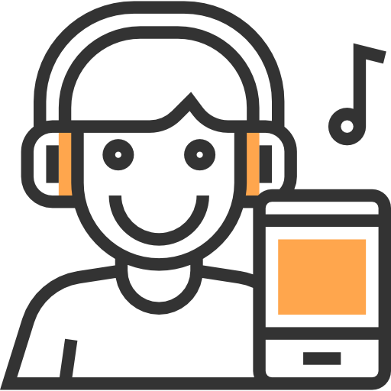
Performance of peripherals
There was a definite appetitive for peripherals to accompany the tablets.
Of those with hearing issues, 34% used the headphones we recommended, 60% still wanted to learn. And 14% of those with visual issues had used the big letter keyboards we advised, yet 57% were keen on learning.
We recommended a stylus for those with dexterity problems, and 52% had used these, while 18% had not but wanted to. For others with dexterity challenges, we suggested keyboards with features like larger letters or a protective grill. These were used by 50% of people, and 25% said they wanted to learn.
Of those we said might benefit from a tablet-holding case/more robust case, 39% said they had used them, while 21% said they were keen to learn.

Impact on community partners
Early results suggest community partners value support.
Almost 93% of organisations said they could better support learners because of our interventions, and nearly 79% are more confident with technology. Nearly 72% said they could work in a more disability-inclusive way. Just over 85% were better able to engage with learners..

Challenges and recommendations
Delivering an emergency response over four months would never be easy, and there were challenges.

Short timeframe for delivery
It took time and effort to engage with community partners and beneficiaries. Some organisations required several calls to set up devices and equipment, and digital skills varied between them. A time-limited approach was at odds with the learning preferences of people with learning disabilities.
Recommendation: future projects would benefit from a longer time frame online workshops to set up devices together for consistency.
Raising awareness of AbilityNet’s support is vital. We continue to support organisations and people through our free services, including our volunteer buddies programme and online Digital Lifeline-related resources.

Communication and contact
Covid-19 restrictions meant that AbilityNet did not always have direct contact with tablet users. When we made follow up contact with support staff, the staff we spoke to were often not the same ones who attended our initial training. This led to the loss of knowledge and risked an inconsistent approach.
Recommendation: Embedding learning and developing initial digital skills gained requires more training and support.

Appetite for adaptations versus adoption
People and organisations found some recommendations easier to embrace than others, with the low take up of complex settings like text-to-speech. However, those who were unable to act on recommendations during the project said they were still interested in learning about such adjustments in future.
Recommendation: AbilityNet's support in Digital Lifeline was presented as optional; a more prescriptive approach could be beneficial. Longer-term support for people to build on digital skills is vital.

Useful Resources and References

AbilityNet Impact Report 2020
https://post.parliament.uk/covid-19-and-the-digital-divide/
ONS: In the year ending March 2018, 13.3% of disabled people reported that they felt lonely “often or always”, compared with only 3.4% for non-disabled people.
https://post.parliament.uk/covid-19-and-the-digital-divide/
Joseph Rowntree Foundation
Source: Mencap
Source: Mencap
Source: Mencap
Source: Disability Rights UK
Action Blocks is available on the Google Play Store
Early results from a poll of 14 organisations

