Beijing Olympics Special Report
In this special report we asked disabled users to try out the Beijing Olympics website in our interaction lab. Poor information architecture and a lack of adherence to web standards result in an uneven playing field for disabled sports fans.
Watch some of the footage of our testing on http://www.abilitynet.org.uk/enation86

Introduction
This special issue of the e-Nation report concentrates solely on the Beijing Olympics website (http://en.beijing2008.cn/). The owners of the last Olympics website were prosecuted under the Australian Disability Discrimination Act. We take a look at both the usability and accessibility of the Beijing Olympics site and ask if disabled sports fans can easily access the games website.
We invited four users with different disabilities into our interaction lab to perform some basic tasks on the website. Users uncovered a variety of accessibility and usability issues which suggest that many users will have a poor user experience when accessing the games website.
The Beijing website has clearly been developed with some accessibility principles in mind, however these have been poorly implemented and we found lots of inconsistencies across pages. What added to the difficulties our users experienced was poor information architecture; this shows how a purely technical approach to accessibility won’t result in a good user experience.

The world is your (potential) audience
There is no audience more diverse than that of a global audience. As a group more than one hundred different languages are spoken, many using different alphabets and reading orders.
A target audience that includes “everyone and anyone” will include new web users, users with slow dial up connections and users with low literacy. There will also be many children who will access the Beijing Olympics site. A global site such as this must cover a range of educational backgrounds and literacy levels.
These days people have a variety of choices for accessing the internet – different browsers, devices, and modes of interaction. For instance more users are likely to access the games via a mobile device, this puts new demands on the website.
Though creating a website that can cope with all these demands is a challenge, following web standards and adopting a user centred approach to accessibility should allow web designers to cater for the most diverse audiences.
Many of the issues we uncovered could have been avoided if web standards were adopted throughout the site.

A level playing field for disabled sports fans?
Sports and the Olympics can bring people together. Today sports fans can access sports information in a growing number of ways both in tradition media and online. Providing information online offers increased opportunity to make sporting information more available to everyone. Are people with disabilities able to enjoy watching and finding out about the Olympics? Do disabled web users have equal choice when it comes to online sports? Our research shows that the Beijing website doesn’t capitalise on the opportunity to make the Olympics more accessible to the broadest possible audience.

What the Beijing website gets right
It is great to see that the Beijing website producers have gone to some effort to consider accessibility for disabled people. They have made available the IBM Easy Web Browsing application, but what else? We would assume that disabled people would use the IBM Easy Web Browser as a last resort if they found it difficult to access the Beijing Web-site without the web browsing technology they already have in place.
Some basic accessibility principles such as including alternative text for images and breaking up pages using headings have been applied but not correctly or consistently.

Our participant with a cognitive impairment was drawn to the Olympic mascots which are used throughout the site. Though this participant found using the site very difficult to use his interest was maintained by the images and cartoon figures.

How we tested the Beijing web site

Selecting tasks and pages
The three main issues that were raised in respect to the SOCOG case where around alt text, access to sporting results, and site navigation. This report concentrates on these issues, as well as other basic issues that affect the accessibility web-sites to disabled people. This will be done by considering tasks that people might typically want to do with the Beijing Olympics web-site.
We gave our participants the following tasks:
- Find out when and where the athletics events are
- What are the qualifying times for the men’s and women’s group A 800m – (sprint)?
- Find out how to get to the national stadium, find information for disabled visitors
- Find a video about the Beijing Olympic mascot
- You would like to attend one of the athletics events, how do you purchase tickets?
- Find information on your favourite athlete

About our participants
We asked four disabled people to help us with testing out the site, all of them had different types of disability, and some used types of assistive technology.
Name* | Disability
Paul | Vision impaired – uses enlarged text size or screen magnification software
Amanda | Blind – uses screen reading software
Bryony | Severe pain in hands – uses voice recognition software
David | Cognitive impairment – does not use any adaptations or assistive technologies
Please note that we have changed the names of our participants.

Findings

Difficulties for users with low vision
The Beijing Olympics site uses a fixed font size, this made it impossible for our participant with low vision to use the website without relying on additional screen magnifying software. If the website was coded correctly users with low vision should be able to browse web pages without relying on expensive additional software.
The site uses a relatively small font size, and it has been fixed in size so that it cannot be changed in Internet Explorer. The default paragraph font has been set to a size of 11pt, which on today’s high resolution computer displays would be difficult to read for a significant number of people.
Paul is trying to increase the font size of the page so that he can read it comfortably, but is unsuccessful. The site does not support adjustable font size as they have been set as absolute values.
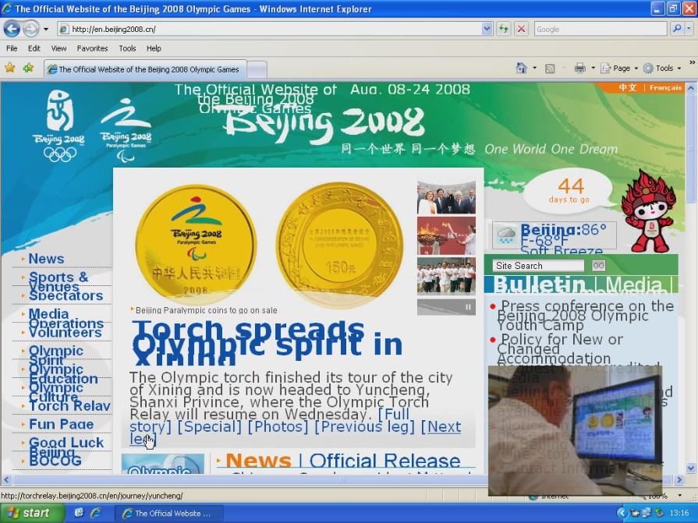
The user can set their browser to ignore font sizes specified by the designers, but this has problems. As in the case of the Beijing Olympics web-site, the use fixed text layout with absolute values such as pixels, means that enlarged text will overlap or will be cropped partway through the text. This is shown in Error: Reference source not found. The fixed layout also means that the page area cannot be adjusted for varying screen dimensions or resolutions.
Figure 1 Paul used the accessibility feature in Internet Explorer to ignore font sizes specified so that he can adjust it to a size comfortable for him. The text is now overlapping and not fitting within the confined spaces making it very hard to use.
Watch a video clip of this issue
http://www.abilitynet.org.uk/enation86#textsize

Difficulties accessing the schedule
One of the key complaints that Bruce Maguire made against the Sydney Olympics website was that he couldn’t access the schedule.
Our research shows that many disabled web users will face similar issues with the Beijing site.
We conducted our testing in the lead up to the games. At this point there was no direct option to get to the schedule in the main navigation. All our participants had great difficulties trying to find the schedule. Though this issue has been corrected once users reach the scheduling page many will face issues including:
- Impossible for a screen reader user to access
- Table layout is not accessible to users with low vision
- Over complicated for a user with a learning disability

Poor Mark-up (or coding) makes it impossible for screen reader users to access
Without the necessary accessible coding this complicated table just sounds like a string of random numbers which are impossible to comprehend.
JAWs screen reading software reads out the table cells from left to right. By the time the first three columns, which just contain numbers have been read out the user is very disorientated.
Watch the video clip of Amanda trying to navigate the schedule. <clip>
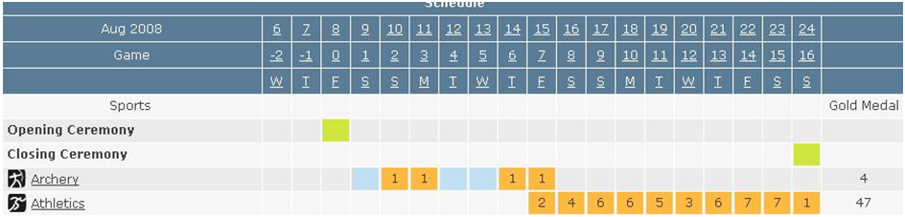
For a screen reader user it is impossible to associate the cells vertically. This is essential to understanding the information in the table.
Figure 1 JAWs reads from left to right row by row, this means it’s impossible for the screen reader user to associate the information in the first two rows.

Layout makes the table difficult for low vision users to access
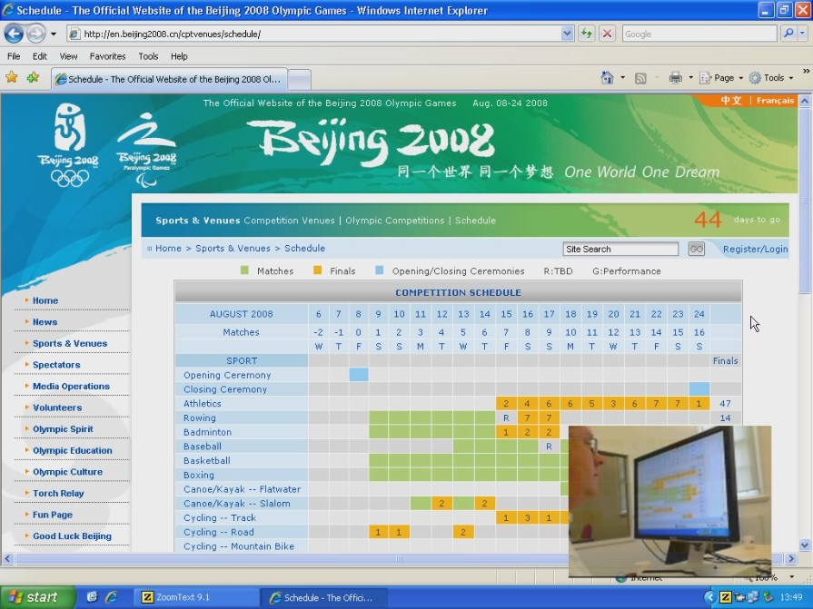
A combination of very complex layout and use of colour to convey information makes the schedule table difficult to understand for Paul. Screen magnification users often magnify the screen by approximately 400%, this means the user can only see a small portion of the screen at a time. Navigating this complex table was difficult under these conditions. The table also relies heavily on colour to convey information. Many web users can’t see colour which would make comprehending the table either difficult or impossible.
Figure 3 Paul has difficulty using this schedule table with screen magnification because he needs to be careful in lining up the columns and rows that are out of the magnified view area. The black dashed rectangle area shows where he is seeing; he is a low magnification setting.

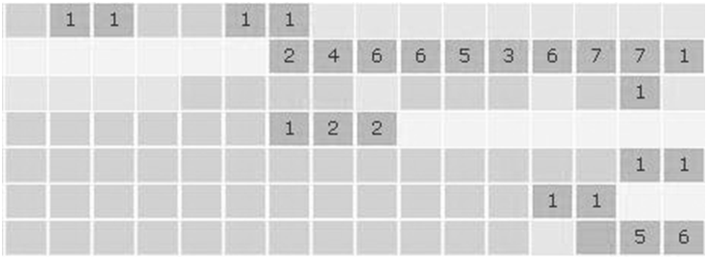
Figure 4 For a user who doesn’t see colour or who is colour blind viewing the table without colour may be difficult

Too complicated for learning disabled users
Learning disabled users require information to be displayed clearly and simply. The schedule table contains information for the whole games. While this is convenient it also creates information overload for any user with a cognitive impairment.

Information Architecture
Our screen reader user does not have the benefit of the visual layout of the page to rely on for signposts such as page titles and headings to orientate herself.
While the visual layout holds some clues for sighted users, it caused difficulties for all our participants, particularly around the use of site navigation including:
- Orientation: understanding where on the site they currently are
- How this relates to the page they were on previously
- Being able to find the page or area they want to go to next

Over complex pages
The home page is very cluttered, and so are most of the other pages across the site. The home page had 87 links at the time of our test. When we reviewed the page the number had increased to 152. This is a lot of information for a screen reader user to process.
Having too many links on a page with little structure proves to be one of the most significant barriers to non-visual users who depend on screen readers and talking web-browsers.
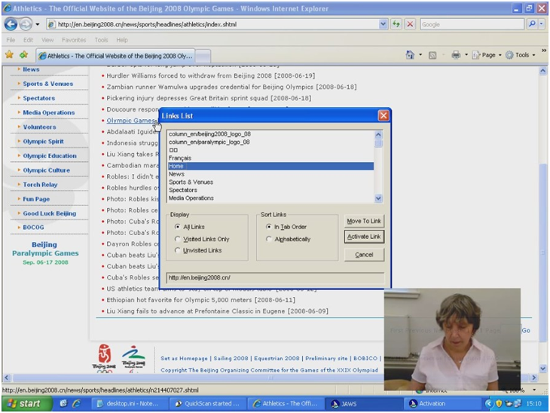
Figure 5 Amanda is using the links list feature in the JAWS screen reader to find a link to take her to the home page. The highlighted area shows links graphic links that don’t have the correct alt text.
Unimportant information given prominence
Our participant with a cognitive impairment gave us refreshingly honest feedback about the page layout. He wondered why seemingly unimportant information was placed prominently on the pages.
Inconsistent pages
There is some inconsistency between the pages, importantly, navigation, and site wide features such as search change position between the home page and sub pages.

No control over video and audio
There are many places across the Beijing web-site where audio has been integrated into the page so that it is played automatically once the page has loaded. For Amanda who needs to be able to clearly hear what her screen reader is saying found it very difficult to continue when she came across these pages. When this happened it often made it so difficult for her to hear her screen reader that she would struggle to get back to the previous page in an attempt to stop the audio playing. This of course meant that many of the pages with lengthy audio where inaccessible to her to use as she did not know if there was a way to stop.

Difficulties for voice recognition software users

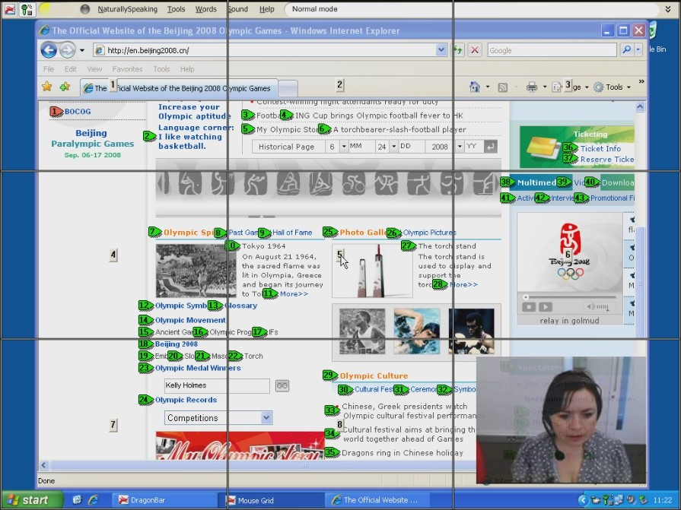
Bryony uses voice recognition software, she avoids using the keyboard and mouse as this can cause her severe pain in her hands. Unfortunately the Beijing Olympics web-site has not been designed well to be supportive of voice recognition users.
Figure 6Bryony relies on using a mouse grid to position the mouse pointer where she would like to click after discovering that the function she wanted to select on the page was in fact not a link.
For example, the search button for the site’s global search feature has not been named; the word ‘search’ that can be seen on the button is only a picture. This means that the voice recognition programme cannot find a button called ‘search’ when Bryony calls out this command. She then has to resort to using the Mouse Grid feature of her voice recognition tool which is rather cumbersome and cognitively demanding and time consuming to her. Error: Reference source not found shows some of the functions available through voice recognition technology for selecting items on the computer screen.

Burying important information
This clip shows how David really struggled to find information about his favourite athlete. He makes several insightful comments about how information which seemed unimportant was placed at the top of the page.
Watch the video clip of this issue
http://www.abilitynet.org.uk/enation86#ia

Other key issues
As well as the issues our user testing uncovered here’s some additional issues we identified:

Poor keyboard navigation
Many people have no access to a mouse. We tested the site using the keyboard only and found that navigating the site had become much more difficult because basic accessibility principles hadn’t been applied. For example there are no skip links that allow keyboard and screen reader user to quickly reach page content. As many keyboard only users experience pain and fatigue in their hands this is a serious accessibility issue.
Also there is no visual change when a link comes into focus to help the keyboard user identify which link they have selected.

Inconsistent design of links
There is no consistent style on the site that visually differentiates links from standard text. For voice recognition software users, who can’t roll over potential links with a mouse this can be a real problem. In this example from the homepage similar styling makes it very difficult to identify a link without using the mouse.
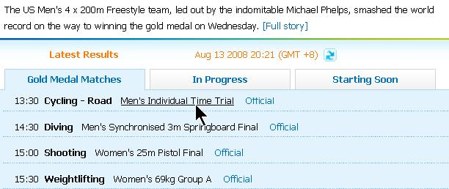
Figure 7 Here the solid lines show links and the dashed lines show non links. There is no standardised visual difference between links and text.

As the games progressed the site has improved
We have been visiting the site regularly over the past few weeks and we’ve noted that lot’s of the accessibility issues we identified during our research have now been fixed. We applaud the Beijing Olympics’ site owner’s efforts to fix the issues we discovered.
In the run up to the games users with disabilities would have had to overcome a lot of obstacles to find information.

These are some of the additional issues we uncovered:
Multinational site - multiple languages
Selecting the link to purchase tickets took users to a page in Chinese language at the time of our testing. This was particularly disorientating for Amanda who uses a screen reader, as she was unaware for quite some time of this and struggled to try and get sense out of what information was available to her. After about five minutes she found her way to the English version of the ticketing site, but had unfortunately ran out of time to discover that she would not have been allowed to purchase tickets from outside of China.

Watch the video clip of this issue
http://www.abilitynet.org.uk/enation86#multilanguage

Difficulties with pop-up windows and inconsistent page design
In this video clip you can see how much our voice recognition software user really struggled to perform a basic task like select the homepage when a pop-up window with a different page layout had been opened.
Watch the video clip of this issue
http://www.abilitynet.org.uk/enation86#popups

Our recommendations
Many of the issues our testing identified could have easily been avoided if basic accessibility principles were applied consistently. This is particularly important for global websites whose audience could be any web user in any country.
If a site uses multiple languages ensure these are coded correctly and tested thoroughly
Information architecture can be a huge barrier to disabled web users if it hasn’t been designed with diverse users in mind. Considering users with cognitive or learning disabilities when creating a site’s structure, when naming links and menu items, is likely to make the overall experience of using a website better and faster for everyone.
Give visual and structural prominence to the most important information, this will allow all users to find what they need quickly.
Use consistent visual and structural styles to guide the user through information.
Testing with real life users can take a site beyond just technical compliance and into a great experience for everyone.

Appendix A - Further Sources of Advice and Support

AbilityNet
www.abilitynet.org.uk
AbilityNet is able to offer information, advice and a range of services to help make a website accessible and usable for everyone – including accessibility audits, disabled end user testing, training, support, accessible web design and a Key Info Pack to get you started.
For further details please call Robin on 01926 312847 or email accessibility@abilitynet.org.uk

Other sources of help and information include:

Web Content Accessibility Guidelines
www.w3.org/TR/WAI-WEBCONTENT
The World Wide Web Consortium (W3C) is the body at the forefront of the development of standards in good design on the World Wide Web (including accessibility). The W3C's Web Content Accessibility Guidelines (WCAG) form the basis of all other standards.

Accessible Rich Internet Applications Suite (WAI-ARIA)
www.w3.org/WAI/intro/aria
Many web applications, such as social networking websites, rely on new scripting languages such as AJAX to allow complex interactions such as re-positioning elements on the screen. The Accessible Rich Applications (ARIA) suite is a series of documents which are working towards making AJAX and related technologies accessible.

Just Ask: Integrating Accessibility Throughout Design
http://www.uiaccess.com/accessucd/
Shawn Henry’s guide to user centred design for all users. Includes information usability testing with disabled people.

RNIB review of the Beijing Olympics website
Part One
http://www.rnib.org.uk/wacblog/articles/beijing-2008-part-one-accessibility/
Part Two
http://www.rnib.org.uk/wacblog/articles/beijing-olympic-website-part-two-internationalisation-080808/
A review of the accessibility and internationalisation of the Beijing website from RNIB.

Equality and Human Rights Commission
http://www.equalityhumanrights.com
(Please note since October 2007 the Disability Rights Commission became part of the Equality and Human Rights Commission)
Organisations are legally obliged to provide websites that are accessible to disabled people. This website includes information on the Disability Discrimination Act (DDA), its accompanying code of practice and their report outlining the findings of research into the accessibility and usability of 1000 websites.

